**Talend Data Integration**

1. Create a new project as AA_1

1. Create a new job as AA1_ECOMMERCE

1. Create file delimited

b

1. Import the dataset

1. Define the setting

Change the field separator as comma, Set the 1st row as header, set heading row as column names.

1. Define the data type – remain as default

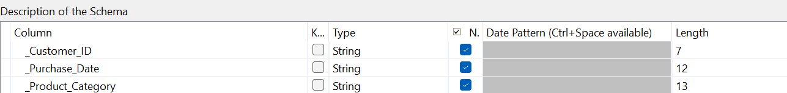

1. Input the dataset by using tFileInputDelimited and use tMap to process the data

1. Setting for tMap

1. Include tLogRow to make sure that without any error

1. Generate output

